The Sacaton Cooperative Agricultural Station:
1907-1924
Pima-Maricopa Irrigation Project Education Initiative
2002-2003

Restoring water to ensure the
continuity of the Akimel O’otham
and Pee Posh tradition of agriculture

Re

When Francis Leupp was appointed Commissioner of Indian Affairs by President Theodore Roosevelt, in 1905, he sought to integrate many of the functions of the Indian Service into other federal agencies. The Indian Service “maintained a little reclamation service, a little forestry branch, and several other minor organizations for work along lines commonly cared for … by special bureaus established by law for the benefit of the American people.” Such “needless multiplication” of government agencies, the Commissioner told Interior Secretary Ethan Allen Hitchcock, in 1908, tended “to retard rather than advance” the work in Indian Country.
Part 36
To this end, Leupp contracted with the US Reclamation Service, in 1907, to build irrigation projects in Indian Country that would benefit both Indians and non-Indians. From this agreement the Reclamation Service began building the Sacaton Project on the Pima Reservation in 1908. Having initiated such cooperative work, Leupp then contracted with the Forest Service to manage portions of Indian forestlands. He then began working with the United States Department of Agriculture (USDA) to assume a cooperative role in agricultural research in Indian Country.
In the fall of 1907 Congress appropriated $5,000 for the Indian Service to begin a cooperative relationship with the Bureau of Plant Industry of the USDA. In October, the Bureau of Plant Industry established the US field station for agricultural research in Sacaton. Operated under a cooperative agreement with the Indian Service, the USDA provided seed, plants and technical staff—and planned the agricultural experiments at the site—while the Indian Service made land, water and labor available. Located just north of the Pima Agency and the modern day Casa Blanca (Little Gila) Canal in Sacaton, two tracts of land—the 55-acre Pima school farm and a separate 10-acre research site—were administered by E.W. Hudson of the Bureau of Plant Industry and M. French Gilman of the Indian Service.
The cooperative station at Sacaton was hailed as “one of the best experimental stations in the western United States.” The facility included a greenhouse, irrigation ditches and a variety of buildings, including a research laboratory. “A row of five tree-shaded residences stretched along the northern bank of the [Little Gila Canal], along with the Experiment Station superintendent’s residence, an agronomists quarter, and a rather large three-story building that contained offices and laboratories.” An official weather station, guest cottages and office buildings rounded out the facility. The Sacaton cooperative station was “shrouded in greenery” and described as “a park setting unto itself.”
The farm was both a research and a demonstration farm. While it was primarily established to identify specific “crops and plants which [had] possibilities of value,” it was also designed to demonstrate the successful cultivation of new plant cultures on the reservation. The 10-acre research site was designed to specifically test “desert and drought resistant plants” while the larger Pima school site was to test the cultivation of fruits, grains, vegetables and trees not then grown within the Gila River Valley. For this purpose, plant studies related to soils and climate were an integral part of the research station.
Leupp expressed great interest in the facility in a 1908 report to Hitchcock and clearly saw the cooperative station as part of the solution to the Pima need for water. The Pima, the Commissioner suggested, had been mislead in believing that groundwater made the land “more alkaline” when used for irrigation purposes. If the United States Government could demonstrate that crops of value could be grown on the reservation “the effect upon the Indians’ fortunes will be most gratifying, as it will substitute hope for discouragement among them [and] incite them to fresh efforts for self-support.”
To a large degree the Sacaton cooperative station was designed to help the Pimas adapt from an agricultural culture based on an abundance of water to one that was dependent on a minimal supply of water. By learning to grow drought tolerant plants and crops, the Indian Service sought to aid the Pimas and Maricopas in making the transition to “new agricultural industries.” Dry-land crops that could “succeed without irrigation” might provide “new crops for culture by the Indians.” Other crops might serve as “object lessons as to the best methods of caring for the crops suited to the climatic and soil conditions” of the southwest.
During its first year of operation, the Bureau of Plant Industry set up a series of demonstrations with crops such as “alfalfa, dates, figs, olives, etc.” The bureau was particularly interested in drought resistant plants that might be adapted to central Arizona. Recognizing that alfalfa was an important crop to central Arizona, the USDA expressed dismay that so little research had been conducted to determine which type of alfalfa might grow best in the heat and soil unique to the desert. To this end, the Bureau of Plant Industry began “a large alfalfa-breeding nursery” in Sacaton, testing over 100 strains from both domestic and foreign sources on just 3.5 acres of land. The objective was to benefit “not only the Indians but the whole farming community of the Southwest.”
Alfalfa was the first experimental crop grown in Sacaton. Hairy Peruvian alfalfa—imported from the South American country of Peru—soon demonstrated its superiority to other types and, by 1920, was recognized as “the best adapted to southwestern conditions.” By growing in the winter, this type of alfalfa would grow when others were dormant. This would produce forage at a time when it was scarce in the desert. By 1920, the cooperative station demonstrated the success of the new alfalfa, which yielded 3.7 tons per acre, nearly twice that of Arizona Common alfalfa.
The USDA reported a “heavy demand” for drought-resistant olives in the United States. Research by the Bureau of Plant Industry in the northern Africa nation of Tunisia found olives growing in climatic conditions very similar to those of south-central Arizona. Importing the plants to the United States and testing them in Arizona and Texas under “dry land conditions” was the beginning of olive research at Sacaton. The cooperative station also grew “wild fruits of value as grafting stock” for almonds, apricots and other fruits. Native drought resistant “grafting stock” would potentially allow fruits to grow in locations they normally would not.
Within its first years, the Sacaton facility was growing apricots, 9 varieties of “citranges,” 13 varieties of Mexican corn—“and some Pima, Hopi and Navajo corn.” In addition, dates, figs, grapes, pecans, pistachios, pomegranates, peaches, plums, onions and strawberries were grown. Nearly all of the labor was provided by the Pimas, whose interest, Leupp boasted, was “greatly enlisted through what they have seen accomplished.” With Pimas working at the cooperative farm, they learned to make adjustments “on their own tracts” of land and began growing some of the new crops on their own farms.
The cooperative station continued to test and grow a wide variety of crops. Bermuda onions planted at the facility produced a 20% increased yield over all other locations in the Southwest. More than 260,000 Bermuda onions were planted in 1911 and distributed in lots of 500 to any Pima or Maricopa farmer interested in growing them. So successful was the crop that the Indians supplied a good portion of the local demand for onions, selling them from $2.50 to $4.00 per hundredweight. Date seedlings, pomegranates, grapes and figs were also distributed to the Indian farmers. A half a dozen varieties of beans were planted in one-quarter acre plots for testing. Mulberries, watermelons and casabas were grown and three acres of sorghum cane was planted, as well.
Wheat, barley and other small grains were soon added to the crops at Sacaton. Wheat—first introduced among the Pimas by Father Kino in 1694—was the number one crop grown by the Pimas in 1919, with 25 rail cars of the grain valued at $80,000 sold that year. The common white wheat (Baart, Sonora and Little Chub) produced the greatest yield. The only challenge growing wheat was “bird damage,” indicating that much of the mesquite forest and cottonwood and willow canopy along the Gila River and its tributaries remained intact. Fields of Baart wheat were grown with just one irrigation in 1924. The USDA particularly enjoyed the Sacaton station for crop studies because “disease is rare and the proper characters of the plants are not obscured by unfavorable climatic conditions or fungus growths.”
Corn studies were conducted using a variety of Indian corns. Between 1921 and 1923, Sacaton June corn (56.8 bushels per acre), San Tan flint corn (40.1 bushels per acres) and Pima soft corn (24 bushels per acre) were the three leading corns grown at the facility. Corn from the Sioux, Hopi, Colorado River, White Mountain Apache and Tohono O’odham reservations were also tested with generally lower yields. The Bureau of Plant Industry attributed the success of the traditional Pima corns to the “short period required for development and their low water requirements.”
Sacaton station proved to be one of the most productive USDA agricultural research stations in the Southwest. Its success directly led to the establishment of similar research stations on the Colorado River (Parker) and Navajo (Shiprock) reservations. Crops tested and grown at Sacaton would soon find their way into production across the Southwest. Orange, lemon and grapefruit tests at Sacaton, for example, helped transform the Salt River Valley into a citrus giant in Arizona. But the Pimas themselves also benefited by learning to grow crops using scarce water resources in a more productive manner. Such crops, while not restoring the traditional agricultural economy of the reservation, did make important contributions to the well being of the people.

Map of Sacaton circa 1932

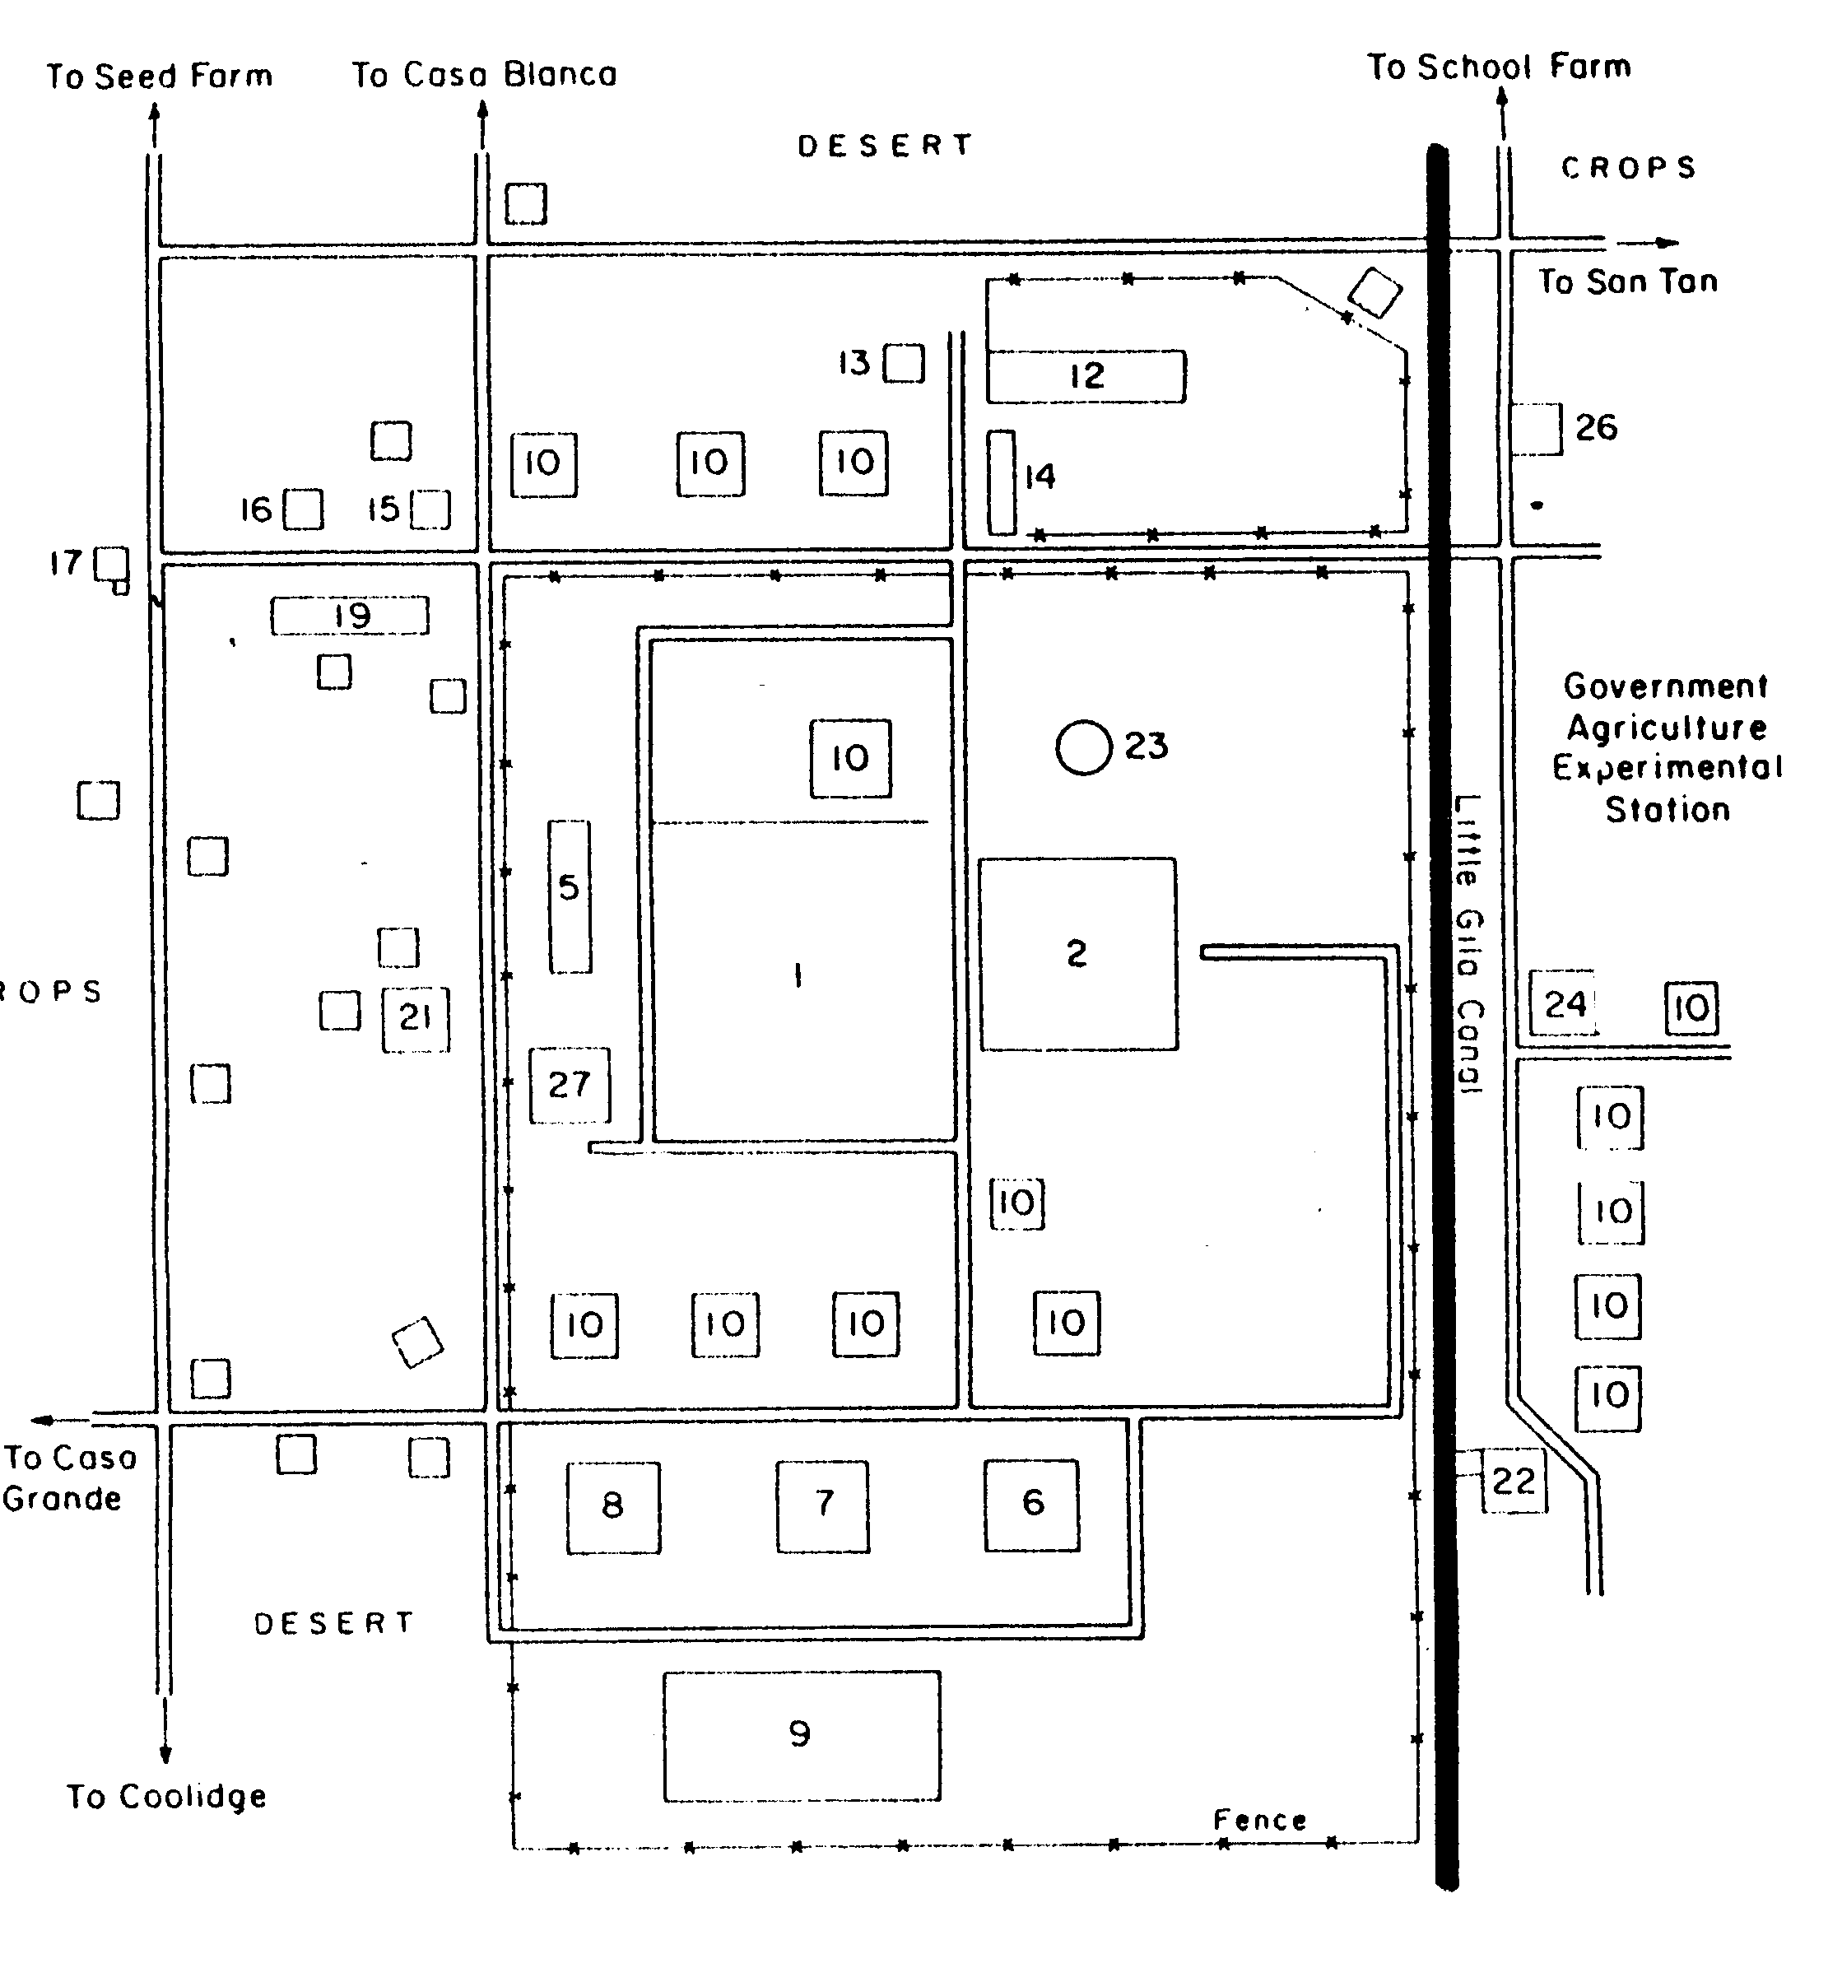
Legend
1 Main agency campus
2 Pima School
6 Indian agency residence
7 Superintendent’s office
8 School superintendent’s office
9 Commissary
10 Employee residences
12 Dairy barn
13 Creamery
14 Brick stables
15 Day school (modern library)
16 Pratt store/post office
17 Catholic Church
19 Presbyterian Church
21 Trading post
22 Flourmill
23 Water tower
24 Pump house and icehouse
26 Cotton gin
27 Boarding house
Indian home
Teacher Plan for “The Sacaton Cooperative Agricultural Station: 1907-1924”
Objectives

Students will be able to:

- Discuss the importance of agricultural research and how it can benefit both farmers and the general population.

- Explain why the Sacaton cooperative station was established and identify some of the crops that were tested at the facility.
Terms to know and understand

- Integrate
- Dry-land crops
- Grafting
- Cooperative
- Drought tolerant
Critical Thinking:

- Why might it be important to identify water-conserving crops to grow in the desert? What might some of the advantages be of having an agricultural research facility in the Community? What are the pros and cons of adapting new crops to a desert environment where they have never been cultivated before?
Activities:

- The Pima-Maricopa Irrigation Project has a team of agricultural development specialists who are researching traditional Pima-Maricopa crops and potentially new commercially grown crops that could be grown within the Community. Invite one of P-MIP’s agricultural development specialists into your classroom to discuss specific research projects that are on-going. They are prepared to speak on topics such as the importance of agriculture, careers in agriculture, what it takes to farm today, traditional and native crops of the Gila River Indian Community, and ways to integrate agriculture into the school curriculum. They can be reached at (520) 562-6700.

- The University of Arizona Maricopa Agricultural Center is a modern day state and USDA research site. UA/MAC provides a variety of agricultural literacy and renewable resources educational programs. These activities provide hands-on learning experiences, interactive learning, tractor rides and other activities for students of all ages. It is a working farm and a research center located south of Casa Blanca near the town of Maricopa. The UA/MAC can be reached by calling the educational outreach specialist at (520) 568-2273. The USDA Natural Resource Education Center in Casa Grande is another excellent program and can be reached by calling (520) 836-2048.
About P-MIP

The Pima-Maricopa Irrigation Project is authorized by the Gila River Indian Community to construct all irrigation systems for the Community. When fully completed, P-MIP will provide irrigation for up to 146,330 acres of farmland. P-MIP is dedicated to three long-range goals:
- Restoring water to the Akimel O’otham and Pee Posh.
- Putting Akimel O’otham and Pee Posh rights to the use of water to beneficial use.
- Demonstrating and exercising sound management to ensure continuity of the Community’s traditional economy of agriculture.

Map courtesy of Ronald Beckwith, in Robert E. Ramsey, “An Oasis in the Desert: The Sacaton Indian Agency in the 1930s—A Photo Essay,” Journal of Arizona History (42:1, Spring 2001), p. 40.

